**Speech Emotion Recognition**

**Kartik Pandey, Aniket Nichat,**

**Rohit Thawali, Sagar Khekale**

**Data science trainees,**

**AlmaBetter, Bangalore**

**Abstract:**

Speech Emotion recognition is a speedly growing research domain in recent years.

In this paper, the basic seven emotions (Angry, Happy, Fear, Neutral, surprise, sad, and disgust) are analysed from emotional speech signals.

Not at all like people, machines cannot see and appear feelings. But human-computer interaction can be progressed by mechanized feelings acknowledgment, in this manner decreasing the require for human intervention

In this project, we used some techniques to develop this project such as KNN, MLP classifier, Decision tree, GRU, LSTM and CNN, and also use some feature extraction and data augmentation

To increase the accuracy of our model.

***Keywords:KNN, Decision Tree, GRU, MLP, LSTM, CNN***

**1.Problem Statement**

Verbal Communication is valuable and sought after in workplace and classroom environments alike. There is no denying the notion that Indians lack verbal communication and consequently lag in the workplace or classroom environments. This happens despite them having strong technical competencies. Clear and comprehensive speech is the vital backbone of strong communication and presentation skills. Where some workconsists mainly of presenting, most careers require and prosper from the ability to communicate effectively.

Research has shown that verbal communication remains one of the most employable skills in both the perception of employers and new graduates. Of the possible improvements to speech, pause, and stutter, in particular, remain one of the most common and prominent factors of someone’s show. Millions of people are affected by stuttering and other speech disfluencies, with the majority of the world having experienced mild stutters while communicating under stressful conditions.

Research shows that mild disfluencies can be cured without medical help, just practicing speech regularly and constructive feedbacks are effective ways to improve. We, Data Scientists recognize this problem and say hello.

**2. Introduction**

In Today’s era the speech has more important because using speech we detect what the feeling of person in various communication field the speech has more important, So What is speech, Speech is nothing but, humans express the feeling and thoughts using coherently sounds, speech emotion recognition easily understand the emotion, Speech is the foremost common way of communicating ourselves as people. It is as it were common at that point to expand this communication medium to computer applications. We characterize speech feeling acknowledgment (SER) frameworks as a collection of techniques that prepare and classify speech signals to identify the inserted feelings.

## **3. Dataset**

### The RAVDESS is a standard multimodal database of emotional speech and song. The database is gender-balanced consisting of 24 professional actors, vocalizing lexically matched statements in a neutral North American accent. Speech includes calm, happy, sad, angry, frightened, surprised, and disgusting expressions, and the song contains calm, happy, sad, angry, and frightened emotions. Each expression is formedon two levels of emotional intensity, with an additional neutral expression. All conditions are available in face-and voice, face-only, and voice-only formats.

### The set of 7356 recordings was rated 10 times each on emotional validity, intensity, and authenticity. The Ratings were provided by 247 individuals that were characteristic of untrained research participants in North America. The next set of 72 participants provided test-retest data. High levels of emotional validity and test-retest intruder reliability were reported. Corrected accuracy and composite "goodness" measures are presented to assist researchers in the selection of stimuli. All recordings are made freely available under a Creative Commons license and can be downloaded at https://www.kaggle.com/uwrfkaggler/ravdess-emotional-song-audio

## **4. Data Augmentation**

Data augmentation is that the method by which we make unused engineered information tests by including little annoyances to our introductory preparing set.

To create syntactic data for sound, we are going to apply commotion infusion, moving time, changing pitch, and speed.

Data augmentation is a technique that it reduces the overfitting of model and act as a regularizer

# **5. Feature Extraction**

In Feature Extraction, we extract features and processing the info.

Broadly highlight extraction procedures are classified as worldly examination and unearthly examination techniques.

In temporal analysis, the speech waveform itself is employed for analysis.

In spectral analysis spectral representation of the speech, a sign is employed for analysis.

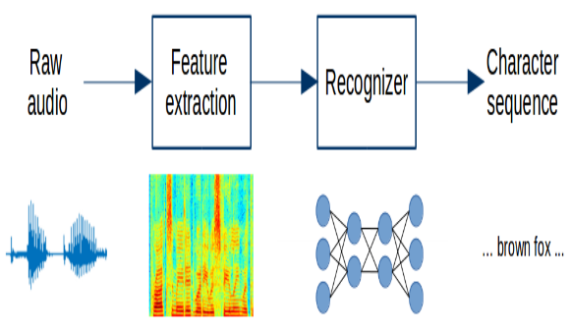

There are few techniques that we are using in this project MFCC and Mel spectrogram this is the feature extraction technique.

**6. Steps involved:**

* **Exploratory Data Analysis**

The First Thing First EDA using this we get intuition about how the data has structed.

After saw the data set first we analysis how many emotion are present in the dataset so after that we got most common seven emotion

It helped us understand which features behave in which ways in relation to the target variable.

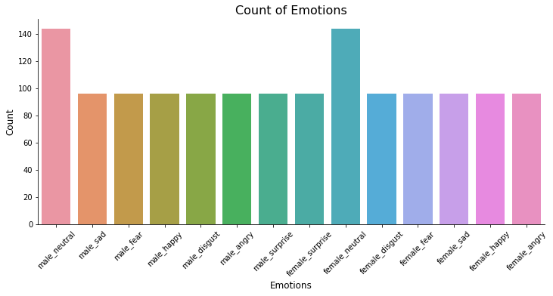

* **Feature Extraction**
* MFCC (Mel Frequency Cepstral Coefficients)- MFCCcan be used to extract the distinctive properties of human voice, and this MFCC also represents the short-term power spectrum of human voice. MFCC is used to produce the coefficients that describe the frequency Cepstral; these coefficients are based on the linear cosine transform of the log power spectrum on the nonlinear Mel scale frequency.
* Mel Spectrogram- A Fast Fourier Transform is computed on overlapping windowed segments of the signal and that we get what's called the spectrogram A spectrogram may be a visual way of speaking to the flag quality, or “loudness”, of a flag over time at different frequencies display in a specific waveform.
* **Fitting different models**

For modeling, we tried various classification algorithms like:

1. **KNN (K-nearest Neighbour)**
2. **MLP Classifier**
3. **Decision Tree**
4. **GRU**
5. **LSTM**
6. **CNN**

**7.1. Algorithms:**

1. **KNN(K-nearest Neighbour):**

KNN belongs to the supervised learning domain and is majorly used in pattern recognition, and data mining. The K-nearest neighbor scheme requires a training set and desired classification for each item

When we need to make a classification for the new data item, its distance to each data in the training set is to be made.

The new data item is then placed in the class that holds the greatest number of items for this set of k closest data items.

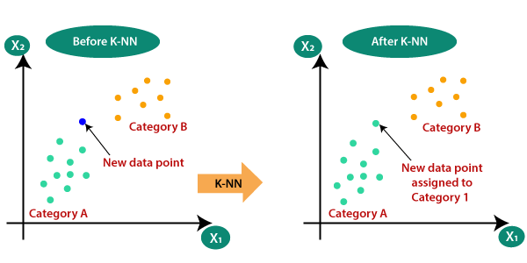

.

1. **MLP Classifier:**

Multilayer perceptron (MLP) classifier is a supervised classification technique that uses backpropagation for training. It is one of the feed-forward artificial neural networks (ANN) classes. It consists of more than one perceptron. It consists of one output layer, one input layer, and in between these input and output layers, there may be an arbitrary number of hidden layers based on the user’s choice. That means it should contain at least three layers input layer, hidden layer, output layer. Expect the input layer; every layer is a neuron that uses a nonlinear activation function. Its nonlinear activation function, multiple layers distinguish this from a single layer feed-forward neural network. Since it has nonlinear activation, it can be able to distinguish the data that is not linearly separable.

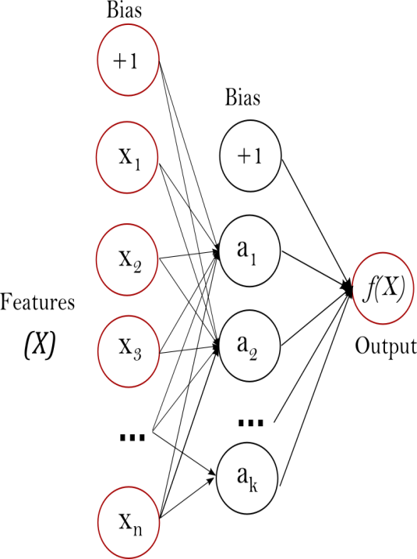

:

1. **GRU (Gated Recurrent Unit):**

In GRU, two gates including a reset entryway that alters the joining of unused input with the past memory and an upgrade entryway that controls the conservation of the valuable memory are presented. The reset entryway and the upgrade door adaptively control how much each covered up unit recollects or overlooks whereas reading/generating a sequence. Gated Recurrent Unit can be utilized to progress the memory capacity of a repetitive neural organize as well as give the ease of preparing a show. The covered-up unit can too be utilized for settling the vanishing slope issue in repetitive neural systems. It can be used in different

applications, including speech signal displaying, machine translation, penmanship recognition, among others.

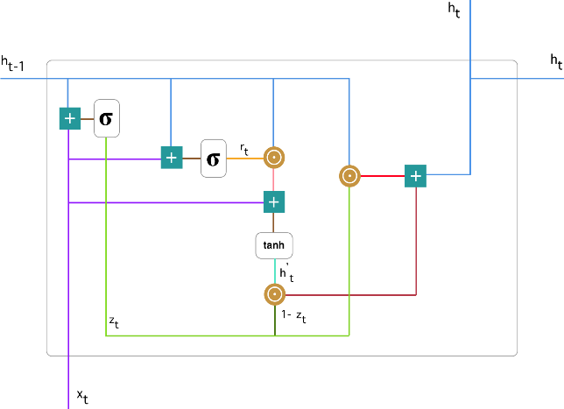

1. **LSTM (Long Short-Term Memory):**

Long Short-Term Memory systems are the special mode of RNN that have the capabilities to memorize long-term conditions and rectify choice to work in a profound assortment of problems. These are specially planned to manage with long-term conditions issues, by default behaviour, they can keep in mind data for a colossal span to time. Like the chain-like structure of rehashing modules of RNN, LSTM incorporates a distinctive structure of the rehashing modules, it has the set of four neural organize layer that connected with each other in a special way.

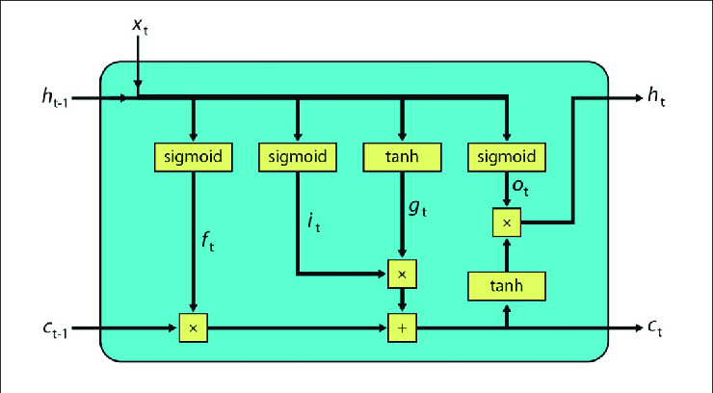

1. **Decision Tree:**

Decision Tree algorithm has a place to the family of supervised learning algorithms. Unlike other supervised learning algorithms, the decision tree algorithm can be utilized for solving regression and classification issues too. The objective of using a Decision Tree is to form a preparing show that can utilize to predict the lesson or esteem of the target variable by learning straightforward choice rules gathered from earlier data (training data). In Decision Trees, for predicting a lesson name for a record we begin from the root of the tree. We compare the values of the root quality with the record’s quality. On the basis of comparison, we take after the department comparing to that esteem and hop to another node.

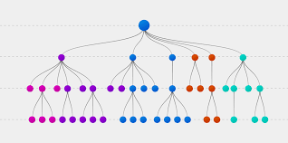

1. **CNN (Convolutional Neural Network):**

Convolutional neural networks (CNNs) are one of the most popular deep learning models that have manifested remarkable success in the research areas such as 14 object recognition, face recognition, handwriting recognition, speech recognition, and natural language processing. The term convolution comes from the fact that convolution—the mathematical operation—is employed in these networks. Generally, CNNs have three fundamental building blocks: the convolutional layer, the pooling layer, and the fully connected layer. Following, we describe these building blocks along with some basic concepts such as SoftMax unit, rectified linear unit, and dropout.

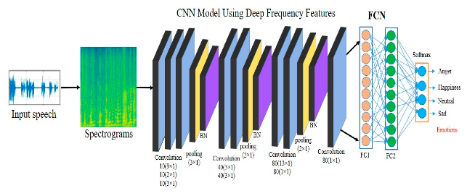

.

**7.2. Model performance:**

A model can be evaluated by various metrics such as:

1. **Confusion Matrix**-

The confusion matrix is a table that summarizes how successful the classification model is in estimating examples related to different classes. One axis of the confusion matrix is the label predicted by model , and the other axis is the actual label.

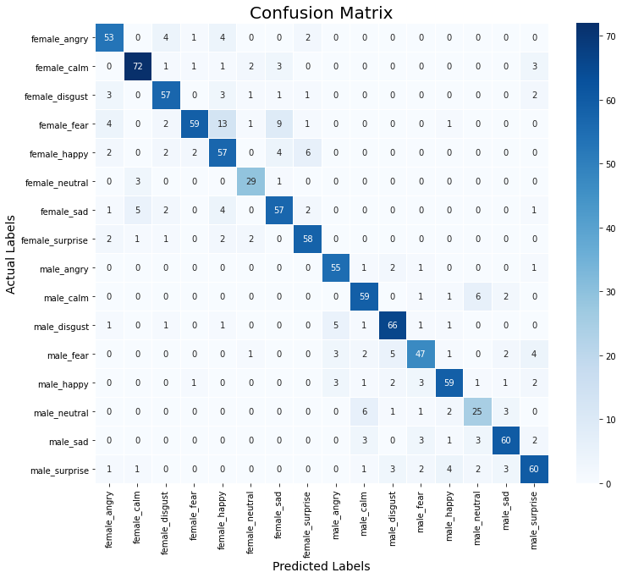

**2.Classifcation Report:**

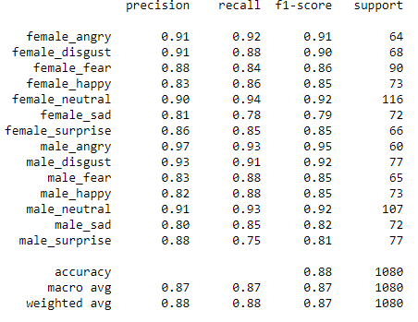

**8. Conclusion:**

That's it! We reached the end of our exercise.

So after all the things do we conclude the paper in this section first use EDA load the data and get intuition about data after that some techniques are use like Data augmentation, feature extraction and model

In model we use six type of model starting from Machine learning to deep learning model in machine learning we use decision tree and KNN after that using deep learning model GRU, LSTM, CNN, MLP classifier

This speech emotion recognition are use in various field like customer care, marketing etc.

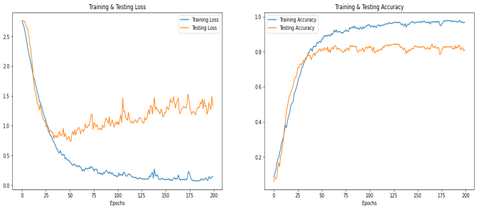

**References-**

* Dong Yu and Li Deng. AUTOMATIC SPEECH RECOGNITION. Springer, 2016.
* Samira Ebrahimi, Vincent Michalski, Kishore Konda, Goethe Roland Memisevic, Christopher Pal― Recurrent Neural Networks for Emotion Recognition in Video‖, Kahou École Polytechnique de Montréal, Canada ; Universität Frankfurt, Germany; Université de Montréal, Montréal, Canada; 2015.
* Ray Kurzweil. The singularity is near. Gerald Duckworth & Co, 2010.
* https://www.analyticsinsight.net/speech-emotion-recognition-ser-through-machine-learning/